Determining the Half-lives of Vanadium-52, Rhodium-104, and an Unknown Element

Contents
Abstract 3
Introduction and Theory 3
Experimental Method 5
GM Counter set up 5
Background Radiation 5
Dead Time of the Detector 5
Sources of Radioactive Nuclei 6
Vanadium Half Life 6
Radioactivity Rhodium Isotopes 6
Element X 7
Measurements, Data Analysis, and Results 7
Dead time of the detector 7
Vanadium 52 7
Radioactivity of Rhodium Isotopes 9
Element X 11
Discussion and Conclusions 13
Dead time of the detector 13
Vanadium 52 13
Rhodium Isotopes 13
Element X 13
References 14

Abstract
Half-lives of Vanadium-52, Rhodium-104 and an Unknown Element were measured using a GM counter. Each GM counter has a specific dead time associated with it: measured to be 378(13) ms. Upon determination of the dead-time, decay rates of each of the elements were calculated from measurements taken for specific time increments, and then their half-lives determined using a least-squares fit to the data. The half-life of Vanadium was measured to be 3,52(7) mins. The result is smaller than the literature value of 3.743(5) mins, and within 4 sigma. The longer half-life of Rhodium was determined to be 4,4(4) mins, while the shorter was determined to be 47(4) s. Literature values are 5 mins for the longer half-life and 40 s for the shorter one: both of which are within 2 sigma of the determined values. Finally, the two half-lives of element X were estimated to be 3,4(5) mins and 74(6) s.

Introduction and Theory
This experiment was composed of multiple complex measurements. The aims of these experiments were to: determine half-life of Vanadium-52; two half-lives of Rhodium-104; and two half-lives of an unknown element, denoted X.
Radioactive decay is a naturally occurring process by which an unstable atomic nucleus loses energy by radiation. Three most common decay types are alpha, beta and gamma decay; each one involves emitting one or more particles or photons. Radioactivity is governed by quantum mechanics and is completely unpredictable on a single atom level. However, predictions can be made for a significant number of identical atoms. Overall decay rate can be conveyed through a decay constant or as half-life. Equation governing the rate of decay of several particles N with respect to time is
$$\frac{dN\left(t\right)}{dt} = -λN\left(t\right) (Equ. 1)$$
where λ is the decay constant [1]. Negative sign indicates that the number of undecayed particles decreases. This differential equation is easy to solve, and the following result holds true
$$N= N_{0}e^{-λt} (Equ. 2)$$
where N₀ is the initial number of radioactive nuclei [1]. The quantity of interest for the measurements is the decay rate ($\frac{dN}{dt}$) and it is obtained by differentiating Equation 2 [1].
$$R= R_{0}e^{-λt} (Equ. 3)$$
The decay constant is a valuable quantity that describes a particular nuclei decay. However, the quantity that is much more descriptive and useful, the quantity this experiment is after is the half-life τ. Half-life is the time after which N is reduced to the half its initial value. Half-life is given by [1]
$$τ= \frac{\ln{2}}{λ} (Equ. 4)$$
Instrument used for measurement of radioactivity was the Geiger-Muller counter. It detects radiation using the ionization effect produced in a Geiger-Muller tube. Tube is filled with an inert gas to which a high voltage is applied. When a particle or photon ionizes the gas, it becomes conductive which is easily detectable.
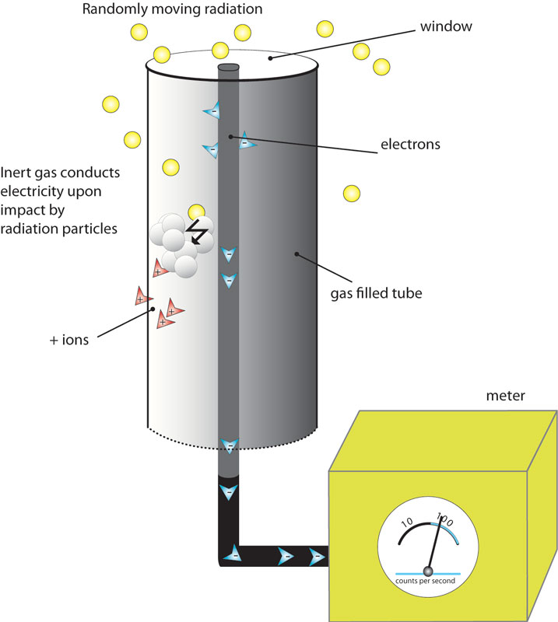
Figure 1 - Process of detecting a single decay in the GM tube [2]
There are two limitations of the Geiger counter. First one is that the output pulse form the GM tube is always of the same magnitude so the tube cannot differentiate between radiation types. Second limitation is the inability to measure high radiation rates due to the dead time of the tube. After detecting a radioactive particle gas needs time to deionize. During this period no new counts will be detected, and the measured count rate is lower than the actual one. To account for this effect all measurements must be corrected using the following formula
$$R_{true}= \frac{R_{meas}}{\left(1-R_{meas}t_{d}\right)} (Equ. 5)$$
where t_{d} is the dead time of the detector [1].
Considering radioactivity is a completely random process (perfect random process) statistical theory is used to make accurate predictions about the decay. The statistics of the decay are those of the Poisson distribution. The Poisson distribution describes the limit of the binomial (atoms can either decay, or not decay) distribution where the probability of the decay of an atom is very small and number of atoms N is very big. Binomial form for the standard deviation of the Poisson limit becomes $\sqrt{Rt}$ so that the Poisson distribution is uniquely determined by its mean. This means that the uncertainty is measurements is always given by $\sqrt{counts}$ [1].

Experimental Method

GM Counter set up
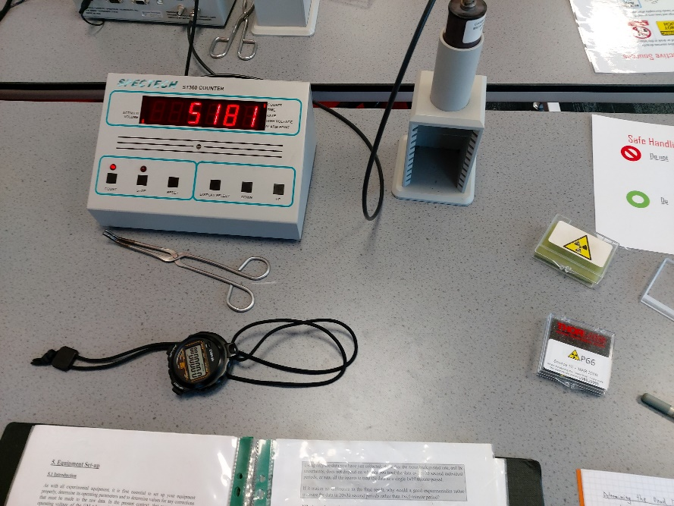
Figure 2 - Equipment used in this experiment. Pictured are the analogue display and the GM tube, stopwatch, tongs and a safe container for radioactive material
GM counters can operate at different voltages; however it is optimal for voltage to be set to a value for which a similar output is obtained for all the charged particles traversing the counter. At this voltage the counter is working at high efficiency. In this experiment, voltage of 900V was used.

Background Radiation
Earth is always being hit by cosmic particles. These particles create what is called background radiation. For radioactive results to be as accurate as possible, effect of this background radiation must be accounted for. Background count was measured for 20 consecutive 30 second periods and thus mean background rate and its uncertainty were determined. This procedure was repeated each day of the experiment to account for possible daily fluctuations in background rate.

Dead Time of the Detector
Main downside of using a GM tube for radiation detection is the dead time of the detector. It had to be determined and all subsequent measurements had to be corrected. The dead time was measured using two radioactive sources that gave true count rates R₁ and R₂. However, because of the dead time the counter displayed count rates R₁’ and R₂’, where R₁’ < R₁ and R₂’ < R₂. Equations connecting the count rates are
$$R_{1}^{'}=R_{1}\left(1-R_{1}^{'}t_{d}\right) (Equ. 6)$$
$$R_{2}^{'}=R_{2}\left(1-R_{2}^{'}t_{d}\right) (Equ. 7)$$
$$R_{12}^{'}=R_{12}\left(1-R_{12}^{'}t_{d}\right) \left(Equ. 8\right)$$
where R₁₂’ stands for measured rate of combined sources and R₁₂ stands for the actual rate of both sources [1]. Using the fact that R₁₂ = R₁ + R₂ above equations reduce to a quadratic equation in t_{d} with solutions [1]
$$t_{d}=\frac{1±\sqrt{1-R_{12}^{'}(R_{1}^{'}+R_{2}^{'}-R_{12}^{'})/R_{1}^{'}R_{2}^{'}}}{R_{12}^{'}} (Equ. 9)$$
Measurements were taken first for the source number 1, then for combined sources 1 and 2, and finally for the source number 2 by itself. This specific sequence of measurements was chosen to minimize the number of changes possible, giving better results. In each case, 10 consecutive 30 seconds intervals were chosen.
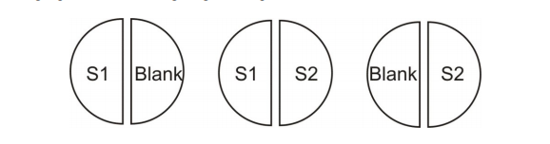
Figure 3 - Order in which sources were placed and their decay rates measured [1]

Sources of Radioactive Nuclei
Throughout the experiment, school’s Americium/Beryllium (Am-Be) neutron source was used. It produces high energy neutrons which are slowed down in the oil bath surrounding the Am-Be source, which makes those neutrons available for other reactions. The source itself is a 40Gbq (1Ci) Am/Be source.

Vanadium Half Life
After receiving the Vanadium sample, it was quickly placed beneath the detector using thongs. Quick placement was necessary to capture the initial quick decay of the sample. Data for Vanadium 52 was collected for a total of 12 minutes, split into 20 second intervals. After each interval, count in that interval was written down and the counter was quickly restarted. Raw counts were corrected for the background rate and the dead-time of the detector. Interval of 20 seconds was chosen because half-life of Vanadium is long enough for 20 second intervals to produce enough measurements, and 20 seconds is short enough to capture correctly the overall shape of the decay. Finally, the data was linearized, and the half-life was calculated using linear regression.

Radioactivity Rhodium Isotopes
Rhodium has two different half-lives and determining them required a different and better measuring method. In this part of the experiment, time interval on the counter was set to a long-time interval and counter was left to count all the total counts. Using a stopwatch to measure time, every 5 seconds total counts until that time were measured. This technique ensured that all the decays were measured, and none were missed. This is an improvement in experimental method which was not used in Vanadium experiment. Again, after receiving the sample it was placed under the counter as soon as possible for the sample not to decay too much and data for determining the shorter half-life is lost.
Knowing the literature values of the two half-life constants, 5 second interval was chosen to measure counts very precisely, for a total of 174 measurements which adds up to 14,5 minutes. Raw data was corrected for the background rate and the dead-time of the detector. This choice of time interval ensured the initial high decay rate was captured precisely, and that the later lower decay rate captured was as well. Measured decay rate was a sum of the two decay curves given by the following equation [1]
$$R\left(t\right)=B+R_{1}e^{-λ_{1}t}+R_{2}e^{-λ_{2}t} (Equ. 10)$$
After enough time had passed, most of the shorter half-life material had decayed and its rate of decay had become negligible. This allowed for calculation of the longer half-life, linearizing the data and using LINEST. Knowing the longer half-life, the calculated longer half-life rate was subtracted from the total measurements, leaving only the rate of the shorter decay rate. This data was linearized as well and half-life calculated using LINEST.

Element X
Procedure for measuring the two half-lives of element X was the same as the one used for Rhodium Isotopes. This time, there were no literature values and the actual values were completely unknown. That is why 10 second time interval was chosen for the count measurement, and sufficiently long time measurements were taken, ensuring the collected data correctly captures both decay rates. The raw data was corrected for the background radiation and dead time. Total decay rate is given by the Equation 10 and after enough time the shorter decay rate becomes negligible. Using this longer time data, longer decay constant was calculated using LINEST. The calculated decay rate of the longer half-life was subtracted from the total decay rate, leaving only the decay rate of the shorter half-life decay rate. This data was linearized and half-life was found using LINEST.

Measurements, Data Analysis, and Results

Dead time of the detector
Before measuring the decay data, the dead time of the Geiger-Muller detector was determined. Count rate for Source number 1 was measured to be 206,4(6) counts/s, count rate of the second source 198,0(6) counts/s and combined rate of both source 1 and 2 was measured to be 375,7(8) counts/s. Using Equation 9 the dead time was calculated $t_{d}=378\left(13\right)ms$. Uncertainty in t_{d} is given by the following equation [1]
$${Δt}_{d}^{2}={(\frac{-1}{2{R_{1}^{'}}^{2}}+\frac{R_{12}^{'}}{2{R_{1}^{'}}^{2}R_{2}^{'}})}^{2}{{ΔR}_{1}^{'}}^{2}+{(\frac{-1}{{{2R}_{2}^{'}}^{2}}+\frac{R_{12}^{'}}{{{{2R}_{1}^{'}R}_{2}^{'}}^{2}})}^{2}{{ΔR}_{2}^{'}}^{2}+{(\frac{-1}{{{2R}_{1}^{'}R}_{2}^{'}})}^{2}{{ΔR}_{12}^{'}}^{2} (Equ. 11)$$
Assuming that the uncertainty in the numerator and denominator of Equation 9 can be calculated separately it can be shown [1]
$$t_{d}=\frac{\left(R_{1}^{'}+R_{2}^{'}-R_{12}^{'}\right)±\sqrt{{\left({ΔR}_{1}^{'}\right)}^{2}+{\left({ΔR}_{2}^{'}\right)}^{2}+{\left({ΔR}_{12}^{'}\right)}^{2}}}{2R_{1}^{'}R_{2}^{'}±\sqrt{2^{2}[{R_{2}^{'}}^{2}{\left({ΔR}_{1}^{'}\right)}^{2}+{R_{1}^{'}}^{2}{\left({ΔR}_{2}^{'}\right)}^{2}]}} \left(Equ. 12\right)$$

Vanadium 52
Data was first corrected for the background radiation and the GM counter dead time.
Linearizing the Equation 3 gives
$$\ln{R=\ln{R_{0}-λt (Equ. 13)}}$$
where R₀ is the initial decay rate and λ is the specific decay constant [1].
Uncertainty in the logarithm value of the decay rate is
$$Δ\ln{R=\frac{{ΔR}_{corrected}}{R_{corrected}}} (Equ. 14)$$
where R_{corrected} stands for the decay rate after both background radiation and the GM counter dead time have been accounted for [1].

Figure 4 - Linearized decay rate over time. Plotted is the logarithm of the background radiation and the dead time corrected rate vs time. Dashed line is a linear best fit line and its equation is shown.

Figure 5 – Plot of residuals over time for the linearized Vanadium-52 data.
Using LINEST half-life was calculated to be 3.52(7) min. There is no trend visible in the residuals data meaning the fit is correct. Approximately two thirds of the residuals do fall within one error bar of the x-axis

Radioactivity of Rhodium Isotopes
The data was first corrected for the background radiation and for the dead time of the counter.
General profile of Rhodium decay rate is given by Equation 10 which when accounted for background radiation becomes
$$R\left(t\right)= R_{1}e^{-λ_{1}t}+R_{2}e^{-λ_{2}t} (Equ. 15)$$
where λ₁ stands for the shorter decay constant, R₁ for the initial amount of the shorter decay nuclei, λ₂ for the longer decay constant, R₂ for the initial amount of the longer decay nuclei [1].

Figure 6 - Natural logarithm of the background and the dead time corrected decay rates over time of Rhodium-104.

From the plot of the logarithm of the corrected rate two lines could be observed. Data was cutoff into two portions, one before 200 seconds and other after. Second part was then treated as separate single decay data, linearized and plotted.

Figure 7 - Corrected decay rate data after 200 seconds over time for Rhodium-104. Dashed line is the linear best fit line, shown is its equation.
Using LINEST longer half-life was calculated to be 4.5(4) min.
Data before 200 seconds was then corrected for the calculated values of the decay rate of the longer half-life isotope
$$R_{1}\left(t\right)=R_{corrected}-R_{2}e^{-λ_{2}t} (Equ. 16)$$
where R_{corrected} stands for the background rate and the dead time corrected data, R₂ and λ₂ for the initial amount and the decay constant of the longer half-life isotope respectively.
Uncertainty in the decay rate of the shorter half-life isotope is given by
$${ΔR}_{1}=\sqrt{{ΔR}_{corrected}^{2}+{ΔR}_{2}^{2}e^{-2λ_{2}t}+{Δλ}_{2}^{2}{(R_{2}te^{-λ_{2}t})}^{2}} (Equ. 17)$$

Figure 8 - Decay data for the shorter half-life over time of Rhodium-104 after accounting for the effects of the longer half-life decay rate. Dashed line is the best linear fit line, shown is its equation.
Using LINEST shorter half-life was calculated to be 47(4) s

Element X
The data was first corrected for the background radiation and the dead time of the counter.
General shape of the collected data is given by Equation 15.

Figure 9 – The background and dead time accounted for decay rates data over time for the unknown element
The data was separated in two segments, one before 400s part and one after 400s. Taking into consideration the shorter half-life decay rate becomes negligible after 400s this data was treated as regular decay given by Equation 3. The data was then linearized.

Figure 10 - Corrected decay rate data after 400 seconds over time for element X. Dashed line is the best linear fit to the data, shown is its equation.
Using LINEST longer half-life was calculated to be 3.4(5) min.
Data before 400s was then corrected for the decay rate of the longer half-life isotope. New decay rate is given by Equation 16 and its uncertainty by Equation 17. That data is linearized and plotted.

Figure 11 - Short half-life corrected data after being accounted for effects of the longer half-life decay rate over time. Dashed line is the best linear fit to the data, shown is its equation.
Using LINEST short half-life was calculated to be 74(6) s.

Discussion and Conclusions

Dead time of the detector
The dead time was calculated to be $t_{d}=378\left(13\right)ms$. Relative uncertainty in t_{d} was calculated to be 0.035, while relative uncertainty in R₁’, R₂’ and R₁₂’ were 0.0029, 0.0030 and 0.0022 respectively. Relative uncertainty in the dead time is much bigger than in the other variables. The reason behind this difference is that the uncertainty in the dead time is governed by a very small difference.
In calculating dead time, simplifying assumption that the uncertainty in the numerator and denominator of Equation 9 can be calculated separately can be made. Relative uncertainty in the numerator is then 0.04 while the one in the denominator is 0.004. Thus, the uncertainty in the dead time is completely dominated by the numerator uncertainty which corresponds to the very small difference$R_{1}^{'}+R_{2}^{'}-R_{12}^{'}$. Uncertainty in this difference skyrockets as the difference becomes bigger, and that is why uncertainty in the dead time is much bigger than the uncertainty in individual R₁’, R₂’ and R₁₂’ rates.
Biggest sources of error in the measurement of the dead time was imperfect changing of the radioactive materials when preparing to take measurements for the next source. Using thongs turned out to be a significant challenge and the resulting geometry of the radioactive sources was certainly not perfectly kept intact.

Vanadium 52
The half-life of Vanadium 52 was calculated to be 3.52(7) min. This is smaller than the literature value of 3.743(5) min. Literature result is within 4 sigma from the calculated value. Since the obtained uncertainty is small, obtained result is precise but isn’t accurate. There were no major sources of error apart from initial inability to precisely measure the decay numbers because they were changing quickly. Method could have been improved using a digital counter instead of an analogue one. This would eliminate any possible human error in writing down the decay rates. The aim of the experiment had been met.

Rhodium Isotopes
The longer half-life was calculated to be 4.5(5) min and shorter one was calculated to be 47(4) seconds. Literature values are 5 minutes for the longer one and 40 seconds for the shorter, both of which are within 2 sigma from the calculated values. There were no major sources of error. Biggest mistake might have been done while measuring the initial decay rates because they change very quickly and are hard to accurately write down. As already written above, digital counter would have improved the method and eliminate any possible human error. Aim of the experiment had been met.

Element X
Two half-lives of the unknown element had been measured to be 3.4(5) minutes and 74(6) seconds. Biggest source of error was the impossibility of completely accurately reading the cumulative count in the early stages of the experiment because of the constant change in counts. Looking up similar half-lives of various elements, none seem to agree with the obtained results. Aim of the experiment had not been met, decay values were not accurately measured.

References
[1] School of Physics and Astronomy 2020, Radioisotopes, Poisson Statistics and Half Lives, University of Edinburgh.
[2]"What is a Geiger counter? - It's a Question of Physics - The Atomic Age - Linda Hall Library - Kansas City, MO", Atomic.lindahall.org, 2020. [Online]. Available: https://atomic.lindahall.org/what-is-a-geiger-counter.html.

